**SOP for ODE Process**

**Description:** How to do Data Entry

**Basic Points:**

**Where do we get Paper (PDF) Invoices from:** We will get invoices through

e-mails.

**Do we have any time limit to complete Data Entry** : We will have 3 days SLA(Service Level Agreement) in that 3 days we need to complete Data Entry in a day and half from the received date and a day and half to do QA i.e., Final checkpoint.

**Where do we work:** We have two business partners, Freight Optics and Audintel. These two business Partners have multiple clients.

Under Freight optics we have 12 clients. They are,

* Chapin International
* Avanti
* Legacy Consumer Companies.

1. The Rewind Company does not require a BOL copy to process.

* Techlight
* Redhawk
* United Scope
* RJTB Group (NKIN=No need of bol as backup docs can be considered as BOL.)

(PO numbers are four digits and sales order numbers are five digits given under ORDER NUMBERS / OWNER'S REFERENCE on the pdf. BOL number cannot be NA).

* Environmental Lights (Files need to be loaded from Junk folder as well)
* Thermon (PO# must for all the carriers, CH Robinson-BOL needed) (FedEx-Capture Class from Invoice copy)
* Globe Scientific
* 1Concier
* Global Logistics
* FloorFound

Under ICC Logistics we have one client.

* FairField

For Audintel we have six clients. They are

* Anixter
* Accu-Tech
* Leslie’s Pool
* Anixter Canada
* Future Electronic
* After Market.

We will work for these clients.

**Step-1:** In Audintel choose the freight tab. Click on Invoice Entry.

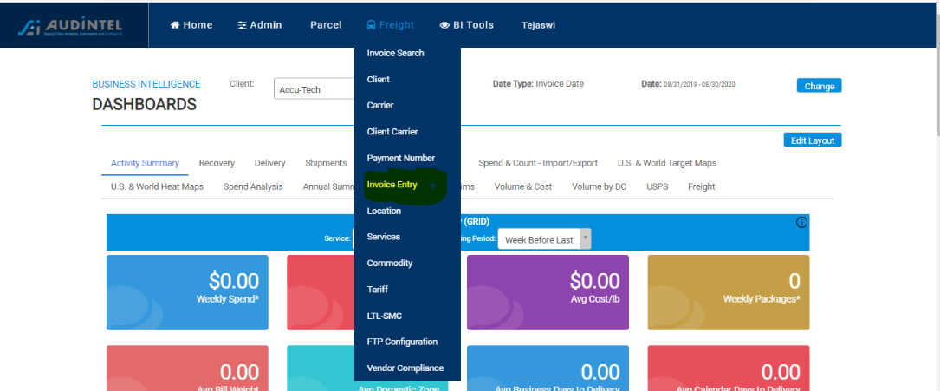

**Step- 2:** Click on Upload tab.

Once you click on upload tab. We should fill these fields by selecting from drop down menu.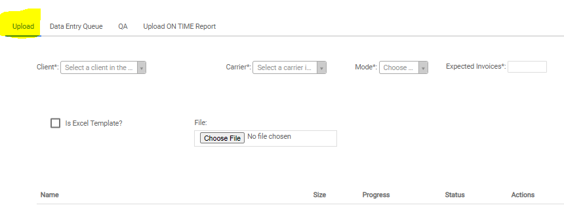

And the fields are

* **Client:** Select the client based on the invoice.
* **Carrier**: Select the carrier name based on the invoice.
* **Mode:** Select Mode of transport from drop down menu.
* **Expected Invoices:** Specify the number how many invoices does the pdf contain**.**
* **File:** By clicking on choose file we can upload the file.

**Note:** File should follow this format

Client name - Carrier name -Excepted invoices count_today’s date

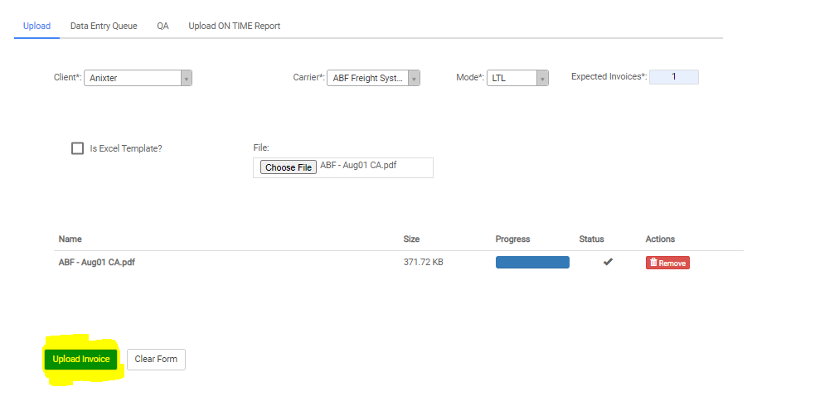

Click on Upload Invoice. Once we upload a file we will get a pop-up that File Assigned Successfully.

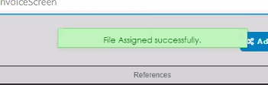

Then the invoice will get uploaded successfully.

**Step-3:** Click on the Data Entry Queue Tab.

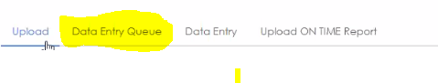

Then multiple files will appear in the list. We need to select the file which we uploaded from the list.

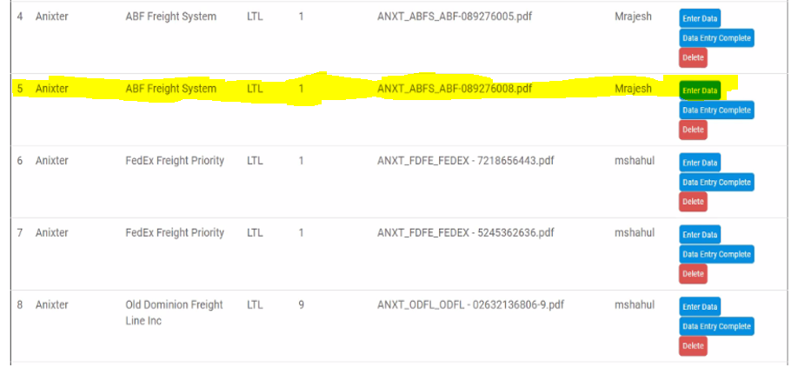

By clicking on the Enter data button to the file which we have uploaded, then we are able to enter the data.

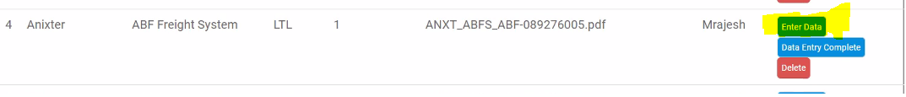

After clicking on Enter data tab We should fill the below fields:

* **Invoice number, BOL number, Po number, Service, Package Description, Invoice Total, Total Pieces, Total Weight, Received Date, Pickup Date, Delivery Date, Payment Method.**

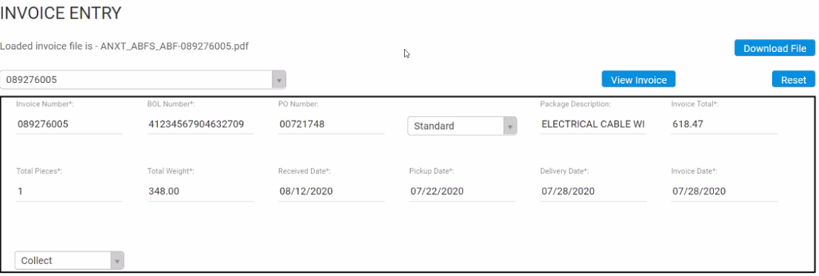

**Note:** Except Received date, all the other fields will be available in the invoice. Received date is nothing but the day which we enter the invoice (Ex: I am entering the invoice today. I will enter the received date as today’s date).

* **Reference Information**

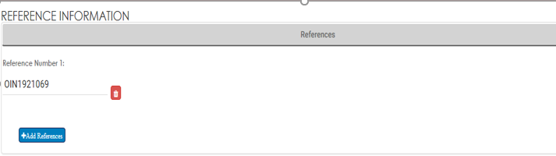

* **Multi-Stop Information:** We will use Multi Stops button when we have multiple Shipper’s and Consignee’s

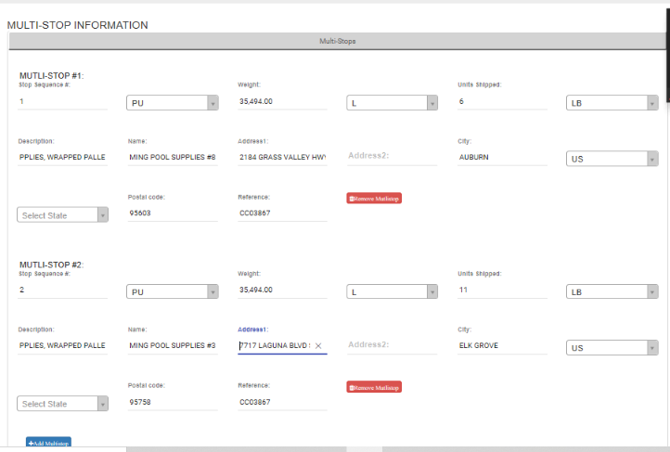

* **Address Information:** This address information contains multiple tabs they are
* Bill to Address
* Shipper Address
* Consignee Address
* Remit to Address
* **Bill to Address**

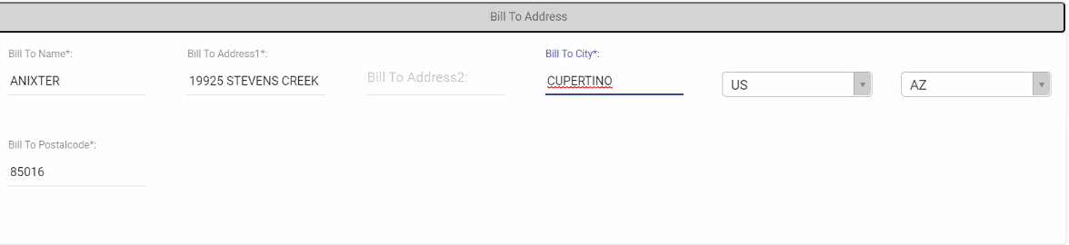

* **Shipper Address**

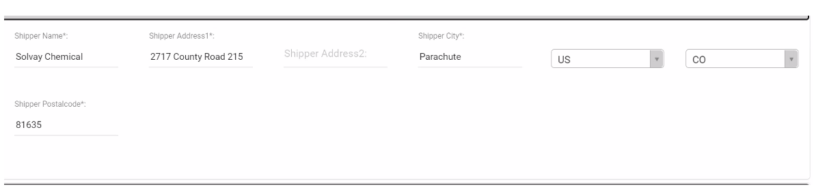

* **Consignee Address**

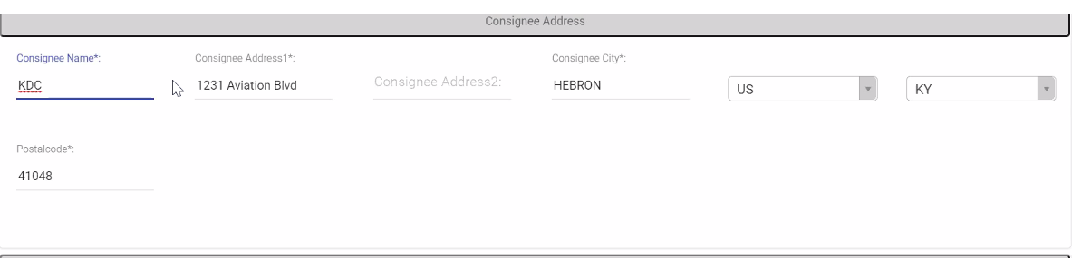

* **Remit to Address**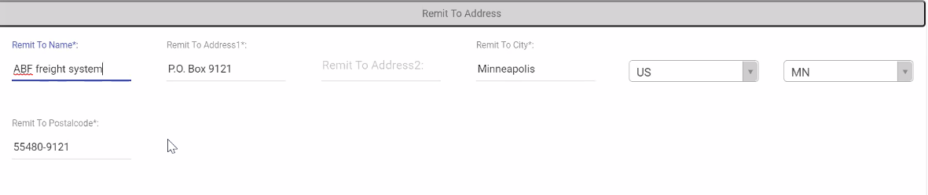

Then click on Add line items tab. To add line items.



Then we can add line items

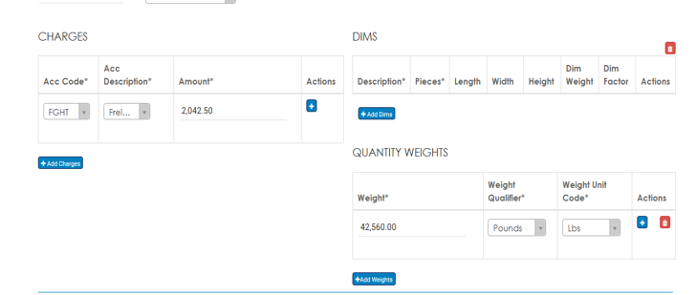

If we have multiple line items then by clicking on Add line items tab, we can add multiples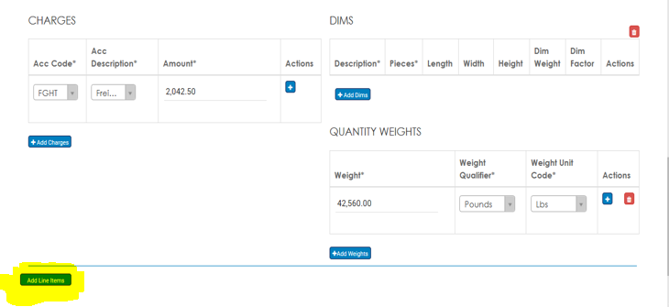

Then after completion of filling these fields. Click on Add invoice then the invoice will add successfully.

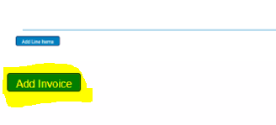

**Step - 4:** Then click on Data Entry Queue. Then you will go back and able to see list of files in that you need to click on the Data Entry Complete.



Once we click on Data Entry Complete. Then we are done with Data Entry. By clicking on Data Entry Complete that file will disappear from the list and it will automatically move to QA list.

**Scenario -1:** Multiple invoices

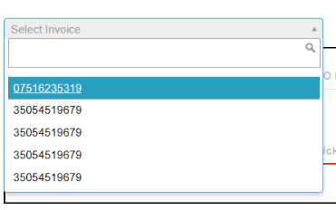

After entering the Invoice, we will click on Add invoice tab. In the same page we can fill all the fields then we will click on Add invoice tab like this we can add multiple invoices in a same file.

**Guideline:** If we have multiple invoices in a same file while uploading a file, we should mention in the expected invoices tab (Ex: In my file there are 7 invoices, so expected invoices should be 7).

**Scenario-2:** Ocean Invoices

When we select Mode as either Ocean FCL or Ocean LCL while uploading a file. These fields will be in addition

* **Move Type**

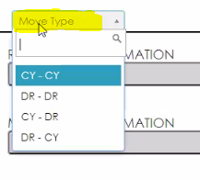

* **Container Information**
  + - Unit: count of the containers(ex:1).
    - Container number: Consider Container number
    - Size: It is available in the Container number (ex: 40HQ).
    - Choose type: Consider DC (Dry Container).

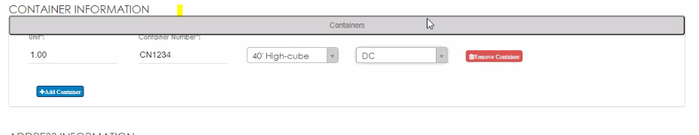

Click on Add Container tab In Container Information. To add more than one container.

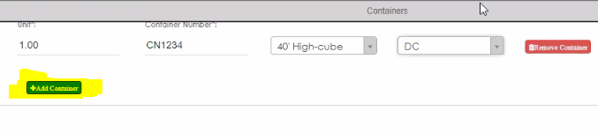

* **Ocean Locations:** In ocean locations field click on Add location tab to add the locations.

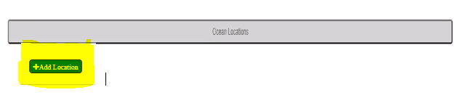

We need to location one is origin and another one is for destination. Ocean location details completely based on Move type. Here we have 2 scenarios.

**Step - 1:** If we choose move type as CY/CY

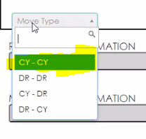

Then we need to select both origin and destination as ports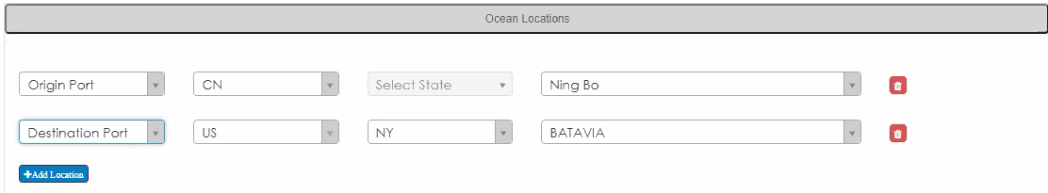

**Step - 2:** If we choose move type as CY/DR

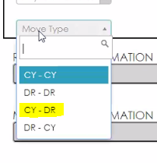

Then we need to select Origin as Port and Destination as Door.

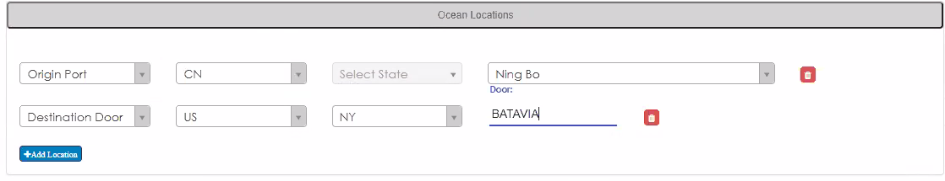

All this Move type, Ocean locations information will be available in the invoice.